­­

**EDIS USER GUIDE**

**GETTING STARTED WITH THE**

**EDIS MOBILE APP**

**(EDIS - Electrical Distribution Information System)**

**www.electricalcertificates.co.uk**

**Date: 26/03/2018 09:00:00**

**After reading this document you should be able to:**

* Download the Mobile app
* Login and download your profile
* Download or Create a certificate
* Upload and complete the certificate

**Contents**

1 PRE-REQUISITES FOR USING THE EDIS MOBILE APP 2

2 GETTING STARTED 2

3 HAPPY PATH FLOW 4

4 CREATING A CERTIFICATE 5

5 IMPORT YOUR PROFILE 7

6 CREATING AND DOWNLOADING CERTIFICATES 9

6.1 Steps to completing a minor works certificate 9

6.1.1 Create Minor Works certificate 9

6.1.2 Edit the certificate 10

6.1.3 Associate boards with a certificate 11

6.1.4 Entering the test data 11

6.1.5 Upload the certificate, View the PDF, Click authorise complete 12

6.2 FINAL STEP TO SIGNING THE CERTIFICATE 12

# PRE-REQUISITES FOR USING THE EDIS MOBILE APP

To use the EDIS Mobile you need the following:

* Registered on the EDIS cloud system
* Estate visibility for your estates
* Permissions and access to the building access

The guide to completing the prerequisites is here: <http://www.electricalcertificates.co.uk/video-registration-and-access>

# GETTING STARTED

1. Download the app:

**ANDROID:** EDIS Mobile on the Google Play store, ***search for*** *“EDIS Electrical”*

**APPLE:** EDIS Mobile on Apple Store, ***search for*** ”EDIS Electrical”

# HAPPY PATH FLOW

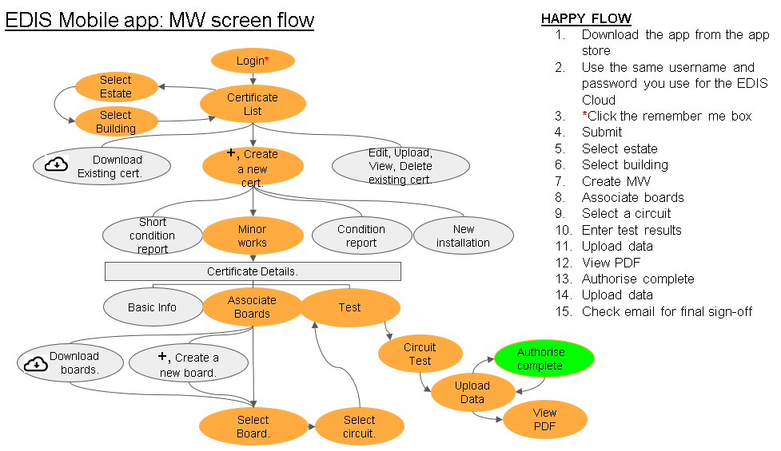

# CREATING A CERTIFICATE

1. Start the app, the app will take a couple of seconds to load
2. Then enter your EDIS email and Password, **Tick the remember me box**

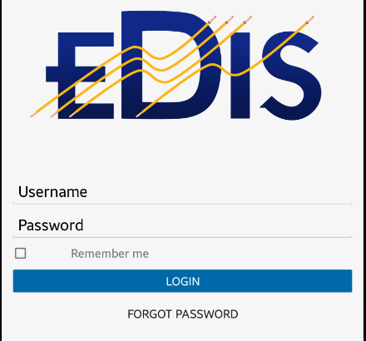

1. After a successful login you will receive messages relating to the Master Data

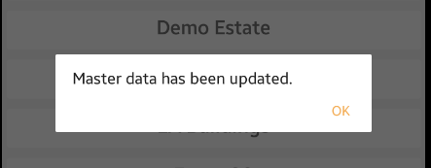

Click OK

1. Select an estate from the Estates list

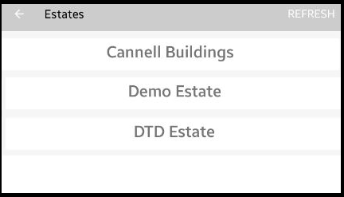

1. Select a building from the building list

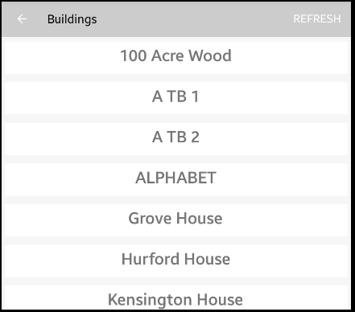

1. You should now see an empty list of certificates

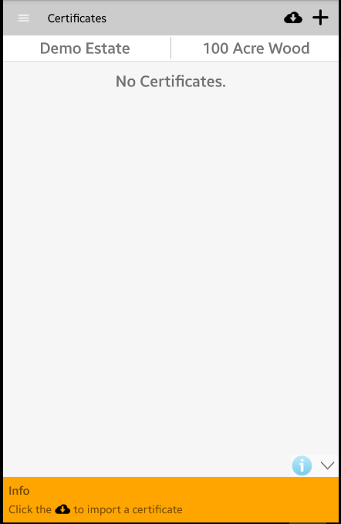

# IMPORT YOUR PROFILE

1. Click the parallel bars on the top left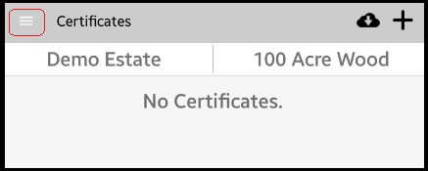
2. The side menu – Click on USER PROFILE

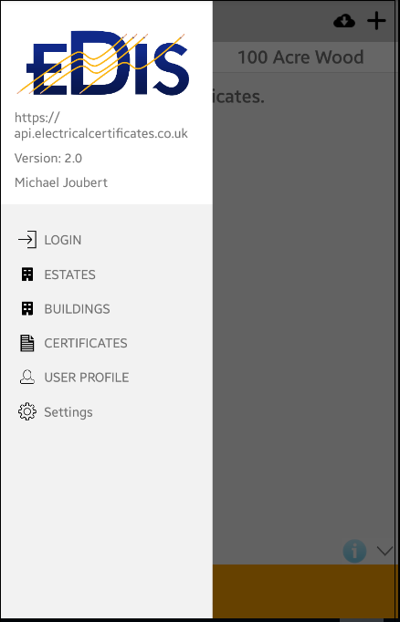

1. Click on Download from cloud to download your user profile - 

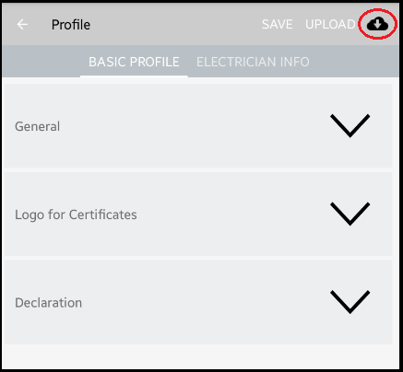

1. Click save

**YOU ARE NOW READY TO CREATE A CERTIFICATE.**

# CREATING AND DOWNLOADING CERTIFICATES

The certificate list will be empty until you download a certificate or create a certificate

## Steps to completing a minor works certificate

### Create Minor Works certificate

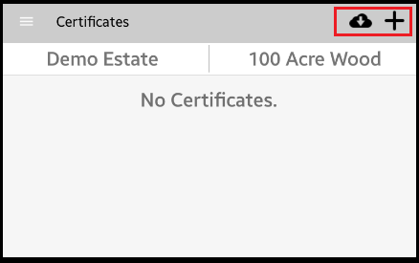

To create a new Minor Works certificate, click the **+** icon. You can also download an existing MW certificate from the EDIS Cloud.

### Edit the certificate

1. After clicking the + button ***or*** downloading the cert the Certificate is shown with three options in the horizonal menus:

* **BASIC INFO** – The basic info screen allows you to edit the Purpose of the report and other general details,
* **ASSOCIATED BOARDS** – The associated boards option allows you to add boards to the certificate or create boards if they are not on the EDIS Cloud
* **TEST** – The Test menu allows you to select the circuit and enter the test results

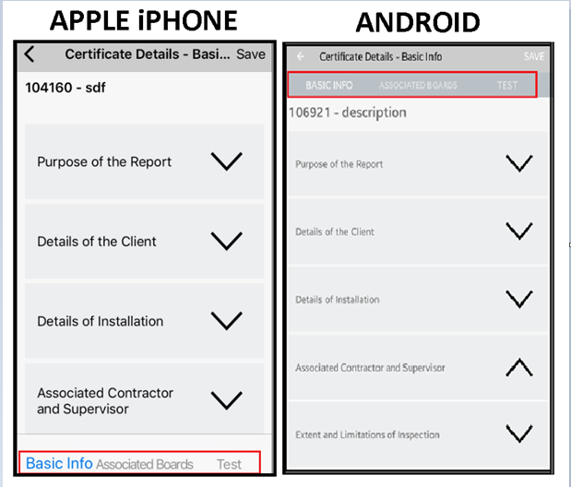

### Associate boards with a certificate

You can create a board, copy a board or download a board. A board must be selected, and a circuit must be associated with the board.

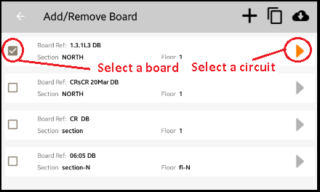

**Tap the 🡨 button to return to the “Basic Info, Associated Boards, Test” menu**

### Entering the test data

Tap the TEST menu option, and enter the results

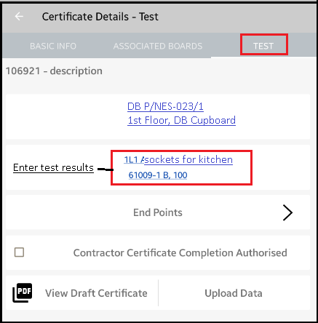

### Upload the certificate, View the PDF, Click authorise complete

After entering the test results, you can upload the certificate, then view the PDF. When you are satisfied with the certificate - tick the “Certificate completion authorised” box and then upload the data.

## FINAL STEP TO SIGNING THE CERTIFICATE

Check your email and click the link that the EDIS Cloud has sent to confirm the completion of the MW.

----end----

For further support : [support@elecricalcertificates.co.uk](mailto:support@elecricalcertificates.co.uk)